How to install your 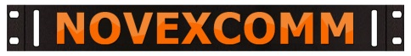 PowerGATE Board Module
Features & capabilities: The GATE board routes DC power from several inputs to the I/O ports
- Arduino microprocessor controls auto-switchover to battery from city power in 20 MS
- Very low voltage drop from DC input to outputs using high-impedance power FETs
- DC input accepts 12-15 volt DC input from an onboard AC supply or external DC input
- Solar input is direct from the solar panel, any size, any rating, no controller needed
- Rig1, Rig2 and Rig3 are the DC outputs at 40 amps total current draw at one time
- Battery is setup for Lithium-Iron Phosphate (LiFE) chemistry 20 AH, SLA/AGM is optional
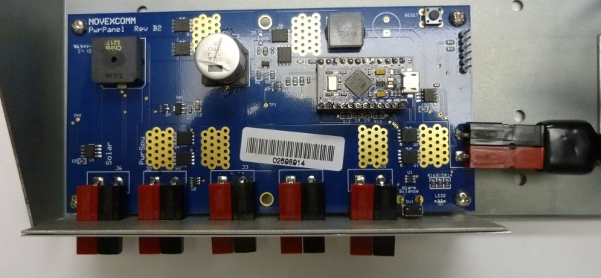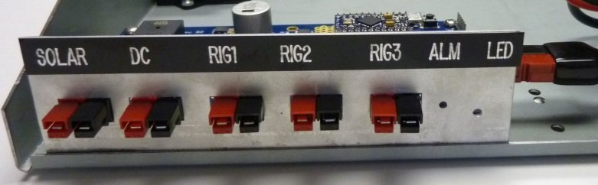
BATTERY INPUT (DISCONNECT WHEN NOT IN USE)
- Set your power supply output for at least 14.5 volts to charge the battery properly
- Crimp on PowerPoles to combine low-current items together wherever possible
- Use at least 16 ga. wire for 10 amp VHF rigs, 12-14 ga. wire for 20-25 amp HF rigs
- Alarm (ALM) button is to stop sounding if the alert is on due to too low battery voltage
- LED flashes to alert on alarm conditions existing and when programming the processor
- Disconnect/ unplug or switch the battery OFF when system is not in use & not charging
- AC power can be left ON indefinitely to float charge the battery when not in use
Primary components for a self-supporting Portable Case “Go Box” are:
- Novexcomm PowerGATE board with stabilizer rear plate as shown above
- 12, 20 or 30 Amp Hour LiFE battery pack bolted to the tray
- 15, 20 or 30 amp Novexcomm DC power supply (if 230 VAC input use the 30 amp unit)
- For a 100 watt HF rig using 22-24 amps expect typical 7-8 hours from a 20 AH battery
CONTACT TODAY AT 310.534.4456 FOR A QUOTE
22826 MARIPOSA AVE. TORRANCE CA 90502 www.NOVEXCOMM.com

